BINARY BAT ALGORITHM
5.1 Modern Optimization Methods
The modern optimization methods (also called nontraditional optimization methods) have emerged as powerful and popular methods for solving complex engineering optimization problems in recent years. These methods are simulated annealing, evolutionary programming (EP), Tabu search (TS), Neural-network based methods, genetic algorithm (GA), differential evolution (DE) algorithm, particle swarm optimization (PSO) technique, seeker optimization algorithm (SOA), ant colony optimization (ACO) algorithm and binary bat algorithm (BBA). Most of these methods are labeled on certain characteristics and behavior of biological, molecular, swarm of insects and neurobiological systems. These new heuristic tools have been combined among themselves and with knowledge elements, as well as with more traditional approaches such as statistical analysis to solve extremely challenging problems.
5.2 Binary Bat Algorithm (BBA)
5.2.1 Description of real bats
Bat algorithm (BA) is based on the behavior of real bats that are the only mammals that can fly. Most of bats especially micro bats use a nature type of sound navigation and ranging (SONAR) called echolocation to communicate, detect the objects such as prey and background obstacles surrounding them and sense the distance to their prey even in the darkness. Bats are capable of emitting a loud with pulse emission rate of sound with specified frequency in the surrounding environment and receive the echo after striking the objects. Therefore, they compute the distance up to the object. Moreover, they can distinguish the difference between prey and obstacle, in addition to the size of objects. BA was first proposed by Yang [4], while the binary version of this algorithm was first introduced by Mirjalili et al. [5]. The approximate rules of the echolocation characteristics based on the features of bats are presented in [6].
5.2.2 BBA mathematical model
BBA algorithm is based on the social behavior of bats for hunting the prey. Bats fly with velocity vector v_{i} at position vector x_{i} with frequency vector λ_{i} in d-dimensional binary search space and these vectors are updated in each iteration. Therefore, the modified velocity of each bat can be calculated using the current velocity and the difference between the current position and the global best among all bats (gbest) multiplied by the frequency as follows [5]:
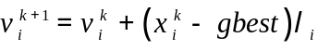 (5.1)
where, v_{i}^{k+1} and v_{i}^{k} are the velocity of bat i at iterations k+1 and k, respectively. x_{i}^{k} is the position of bat i at iteration k, gbest is the best solution obtained so far, and λ_{i} is the frequency of bat i which can be calculated as:
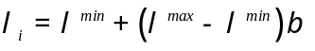 (5.2)
where, λ^{min} and λ^{max} are the minimum and maximum limits of frequency, respectively. β is a random number of a uniform distribution in the range [0,1]. Bats change their positions according to the probabilistic transition rule that depends on their velocities. The probabilistic transition rule should be restricted in the range [0,1]. Therefore, the probabilistic transition rule of bat i at iteration k can be expressed as [5]:
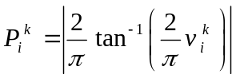 (5.3)
Now, the position of bat i at iteration k+1 can be flipped based on the probabilistic transition rule as [5]:
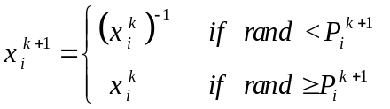 (5.4)
where, x_{i}^{k+1} and x_{i}^{k} are the positions of bat i at iterations k+1 and k, respectively, while (x_{i}^{k})⁻¹ is the complement of x_{i}^{k} up to the maximum value. After that, the bat positions are updated based on the pulse emission rate (r_{i}) and random value as:
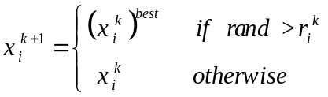 (5.5)
where, (x_{i}^{k})^{best} is the best position of bat i at iteration k, and r_{i}^{k} is the pulse emission rate of bat i at iteration k. After the global best solution is achieved, both the loudness and the pulse emission rate of bats should be updated, where the loudness should be decreased, while the pulse emission rate should be increased as follows [5]:
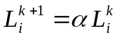 (5.6)
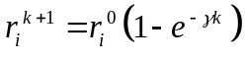 (5.7)
where, L_{i}^{k+1} and L_{i}^{k} are the loudness of bats at iterations k+1 and k, respectively. r_{i}^{k+1} is the pulse emission rate of bats at iteration k+1, while r_{i}⁰ is the initial value of the pulse emission rate. α and γ are constants, where α lies between 0 and 1, while γ is greater than zero. Finally, the position vector is updated based on the procedure of random walk as follows:
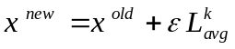 (5.8)
where, x^{new} and x^{old} are the updated and old values of bats positions, respectively. ε is a random number in the range [-1,1] and L_{avg}^{k} is the average loudness emitted from all bats at iteration k.
5.2.3 BBA Algorithm
The process of BBA for solving the optimization problems can be summarized as follows:
Step 1: Initialization
Insert the follows:
- Insert the control variables or bat positions that represent the locations and sizes od DGs and capacitors between the minimum and maximum limits as follows:
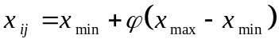 (5.9)
- Insert the BBA parameters, number of bats (N_{bats}), α, β, γ, ε, λ_{min} and λ_{max}.
- Insert the initial values of the loudness (L_{i}) and the initial pulse emission rate (r_{i}⁰). In addition, initialize the bats velocity and frequency.
- Insert the candidate buses.
- Create a search space with dimensions (N_{bats} x N_{can}), where N_{can} is the number of candidate buses.
Step 2: Provide bat first position
Each bat is positioned randomly within the reasonable range of each control variable in a search space with one bat at each position in the length of randomly distributed values.
Step 3: Initial evaluation
For each bat, calculate the initial value of objective function with the candidate buses in the search space as:
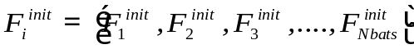 (5.10)
Step 4: Check the system constraints
For each bat, check the system constraints in Eqs. (3.2)-(3.12) based on the values of control variables to accept the values of objective functions that correspond to the bats satisfying the system constraints.
Step 5: Initial global best solution
For accepted solutions after checking constraints, the initial global best solution (g_{best}^{init}) can be determined according to the objective function.
Step 6: Probabilistic transition rule
For each bat, calculate the velocity vector from Eq. (5.1). Then, each bat changes its position in the range of control variables according to the probabilistic transition rule in Eq. (5.3). The bat positions or control variables are modified as the following steps:
- Calculate the probability using Eq. (5.3) for each bat.
- If P_{i}^{k+1} < rand, the bat position (x_{i}^{k+1}) is modified to be the complement of the bat position (x_{i}^{k}). Otherwise, the bat position (x_{i}^{k+1}) is kept as the position (x_{i}^{k}).
- Repeat the previous steps for bat-times.
- Get the final form of the modified control variables.
Step 7: Search space updating
For each bat, the control variables can be updated using Eq. (5.5).
Step 8: Fitness function
After updating the search space, the objective function can be determined for each bat at iteration k as:
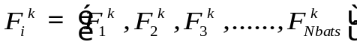 (5.11)
Step 8: Check the system constraints
For each bat, check the system constraints in Eqs. (3.2)-(3.12) based on the updated control variables to accept the values of objective functions that correspond to the bats satisfying the system constraints. Therefore, the global best solution (g_{best}) at the current iteration can be obtained.
Step 9: Global best solution
For accepted solutions after checking constraints, the global best solution (g_{best}) at iteration k+1 can be determined as:
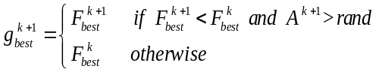 (5.12)
Step 10: Control variables, loudness and pulse emission rate updating
After the optimal solution is obtained at the current iteration, the control variables, loudness and pulse emission rate are updated using Eqs. (5.6)-(5.7).
Step 11: Check stopping criterion
The program will be terminated when the maximum iteration is reached or the best solution is obtained.
The flow chart of the BBA to find the optimal solution is shown in Fig. 5.1

Start
Initialization; Insert BBA parameters, control variables, candidate lines, initialize bat position, velocity, frequency, pulse emission rate, the loudness and create the search space
Check the system constraints
Determine the initial global best solution
Generate the initial position randomly of each bat
Initial evaluation process
Apply probabilistic transition rule
Search space updating
Determine the Fitness function
Check the system constraints
Determine the global best solution
Control variables, loudness and pulse emission rate updating
Check stopping
criterion?
Get the optimal solution
No
Yes
Fig. 5.1 Flow chart of BBA

